DFWI Sport and Leisure Sub-committee

Overnight visit to the

National Memorial Arboretum, Staffordshire.
https://www.thenma.org.uk/visit-us/plan-your-visit

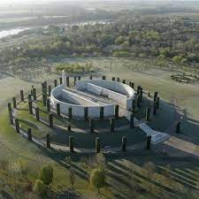

18th – 19th September 2024

Staying at the Mercure Birmingham West Hotel
https://all.accor.com/hotel/B538/index.en.shtml?utm_campaign=seo+maps&utm_medium=seo+maps&utm_source=google+Maps#section-facilities

1 night dinner, bed and breakfast

Pick up points: Newton Abbot; Exeter Services M5 Junc 30; Junc 27 M5

Cost: £180 - members (shared twin room)
£190 - non members (shared twin room)
Single supplement +£30

Itinerary
Day one – travel to the hotel with a lunch break en route. Dinner at the hotel

Day two – short journey to the Arboretum to arrive in time for the daily Act of Remembrance (optional), remainder of the day spent at leisure at the Arboretum leaving late afternoon for return to Devon

Booking form with your secretary

